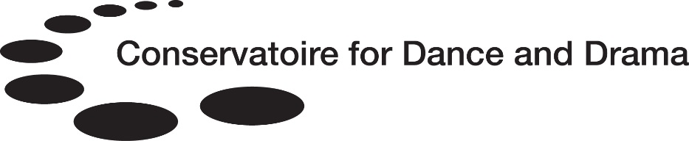

RISK ASSESSMENT

PRIVATE AND CONFIDENTIAL

This form may be used by officers of the Conservatoire in conducting any of the procedures under the Policy on Sexual Misconduct, Harassment and Related Allegations, including to assist with determining whether Precautionary Measures may be necessary.
This form must be kept strictly confidential, as it may contain special category and/or criminal records data. It should only be shared on a strictly necessary basis.
Student Details
Student Name
Student Number
Conservatoire School
Programme of Study

Year of Study
Date of risk assessment

The following page contains the Risk Assessment Score System, where a score will be given for both ‘likelihood’ of the risk occurring, and how serious or extreme the impact of the risk would be, in the view of the assessors. The Overall Score is then calculated by multiplying the likelihood and impact score together for each ‘element’, to give an overall score for each element, and used to determine whether action is required.
In order that an objective assessment be made, it is recommended that two officers of the Conservatoire complete this form, and that one of the officers be a Conservatoire School Principal or senior member of staff from either the relevant School or the central Conservatoire office. Where the above is not possible, for example, due to time constraints or staff availability, this form may be completed by one individual but reviewed and signed off by an additional senior member of staff.
Staff should ensure that form is fully completed and that the dates that the risk assessment is both undertaken, and signed off, are both entered.

- Risk Assessment Score System

Table 1
Score | Likelihood  This score indicates how likely the risk is to occur, in the view of the assessor(s). | Impact  This score indicates, in the view of the assessor(s), how serious/extreme the impact would be.
1 | Highly Unlikely | Negligible
2 | Unlikely | Minor
3 | Possible | Moderate
4 | Likely/Probable | Major
5 | Highly Likely | Extreme

Overall Score
This score is calculated by multiplying the likelihood and impact score together for each ‘element’, to give an overall score for each element.

Table 2
Score | Risk Category
1 – 8 | LOW
9 – 15 | MEDIUM
16 – 25 | HIGH

- Likelihood Score
Element |  | Likelihood
 |  | 1 | 2 | 3 | 4 | 5
 |  | Highly Unlikely | Unlikely | Possible | Likely / Probable | Highly Likely
1 | Risk to self
2 | Risk to other students
3 | Risk to staff
4 | Risk to public / others
5 | Risk to successful completion of programme of study
6 | Risk to placement / external activity
7 | Risk to School and/or other CDD property
8 | Risk to School and/or CDD reputation

- Impact Score
Element |  | Impact
 |  | 1 | 2 | 3 | 4 | 5
 |  | Negligible | Minor | Moderate | Major | Extreme
1 | Risk to self
2 | Risk to other students
3 | Risk to staff
4 | Risk to public / others
5 | Risk to successful completion of programme of study
6 | Risk to placement / external activity
7 | Risk to School and/or other CDD property
8 | Risk to School and/or CDD reputation
- Overall Risk Assessment
Element |  | Likelihood Score | Impact Score | Overall Score  (Likelihood Score multiplied by Impact Score) | Comments
1 | Risk to self
2 | Risk to other students
3 | Risk to staff
4 | Risk to public / others
5 | Risk to successful completion of programme of study
6 | Risk to placement / external activity
7 | Risk to School and/or other CDD property
8 | Risk to School and/or CDD reputation
- ACTION IS REQUIRED WHEN:
  - There are three or more MEDIUM RISK categories indicated
  - There is one or more HIGH RISK category indicated

(see section B, Table 2 for reference)

Notes regarding overall risk / other risk(s) / pertinent information / additional comments
(Please use this box to indicate whether the results of the risk assessment indicate that Precautionary Measures are necessary.

- Completion of the Risk Assessment
(All members of staff who have completed, or assisted in completing the risk assessment (including reviewing for sign-off), should complete and sign the box below. Additional rows for entering this data can be added as necessary.)
Name(s) of person(s) who completed the risk assessment | Role / Job Title | Signed | Date

